Menu Structure:



Search user input

Time Occurrence user input

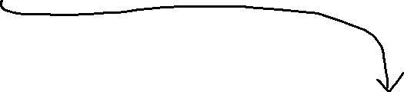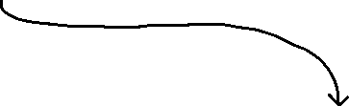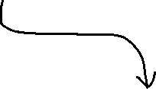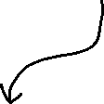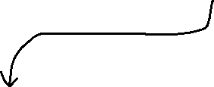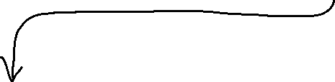

Exit Program

Find and print the slowest time

Time Occurrence

Search

Find and print the fastest time

Sort and print recorded times

Read and display file

Main menu

Password input